CNN Architecture & LeNet-5
This document provides a detailed overview of Convolutional Neural Network (CNN) architecture, focusing on its fundamental components and a foundational model, LeNet-5, as discussed in the provided sources.

1. Introduction to CNN Architecture
- What is a CNN?
  - A Convolutional Neural Network (CNN) is a type of neural network used primarily for image processing and classification tasks.
  - It is built upon a combination of three core ideas: convolution operation, padding and stride, and pooling.
  - Understanding how to integrate these concepts is crucial for creating a CNN architecture.
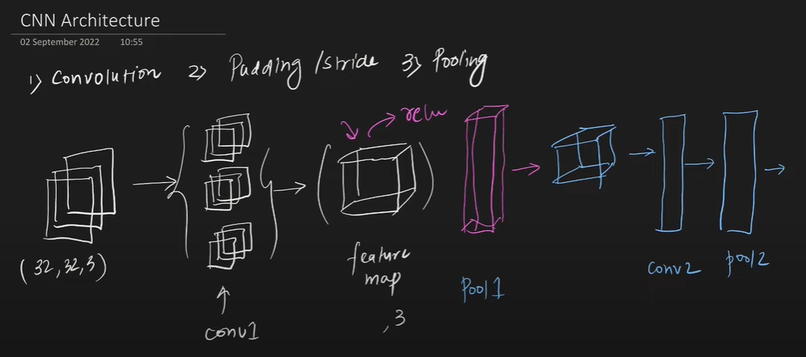
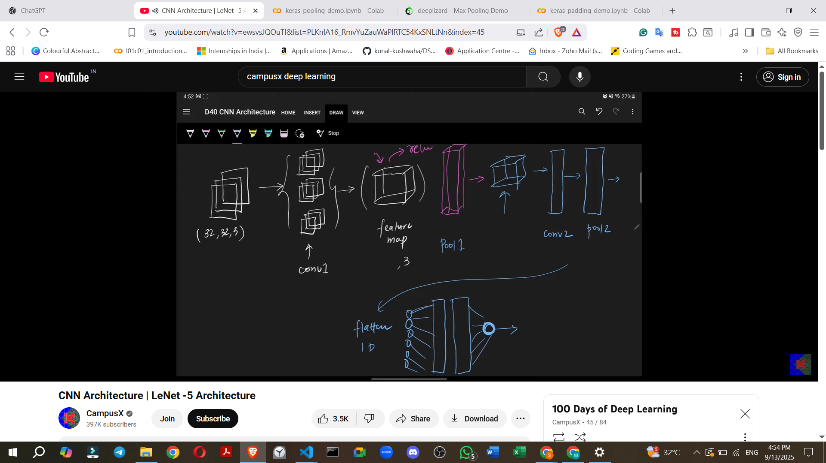

2. Basic CNN Architecture: A Sequential Overview
How does a typical, basic CNN look, layer by layer?
- Input Layer:
  - Purpose: Receives the raw image data.
  - Example: Often an RGB image, e.g., 32x32 pixels with 3 channels (for Red, Green, Blue).
- Convolutional Layer (Conv Layer):
  - Purpose: Applies filters (also called kernels) to the input to extract features.
  - Process: Filters slide across the input, performing convolution operations.
  - Output: Generates a feature map (a volume of numbers). The number of feature maps depends on the number of filters used.
  - Key Question: How many filters should be used in a convolutional layer?
- Non-linear Activation Function:
  - Purpose: Introduces non-linearity into the model, allowing it to learn more complex patterns.
  - Placement: Typically applied immediately after a convolutional layer.
  - Example: ReLU (Rectified Linear Unit) is a common choice in modern CNNs.
- Pooling Layer:
  - Purpose: Reduces the spatial dimensions (width and height) of the feature maps, thus reducing the number of parameters and computational cost, and providing some invariance to small shifts and distortions.
  - Placement: Usually follows a convolutional layer and activation function.
  - Example: Max Pooling or Average Pooling.
  - Flexibility: You can apply multiple combinations of convolutional and pooling layers to progressively extract higher-level features.
- Flattening Layer:
  - Purpose: Converts the multi-dimensional output from the convolutional/pooling layers (a 3D tensor) into a one-dimensional vector.
  - Necessity: This prepares the data to be fed into fully connected layers.
- Fully Connected Layers (FC Layers):
  - Purpose: These are standard neural network layers where every neuron in one layer is connected to every neuron in the next layer. They perform high-level reasoning based on the features extracted by earlier layers.
  - Placement: Applied after the flattening layer.
  - Flexibility: You can use multiple fully connected layers depending on the problem.
  - Key Question: How many nodes should each fully connected layer have?
- Output Layer:
  - Purpose: Produces the final prediction of the network.
  - Structure:
    - For binary classification, typically a single node with a sigmoid activation function.
    - For multi-class classification, multiple nodes (one for each class) often with a Softmax activation function.
  - Example: For digit recognition (0-9), there would be 10 output nodes.
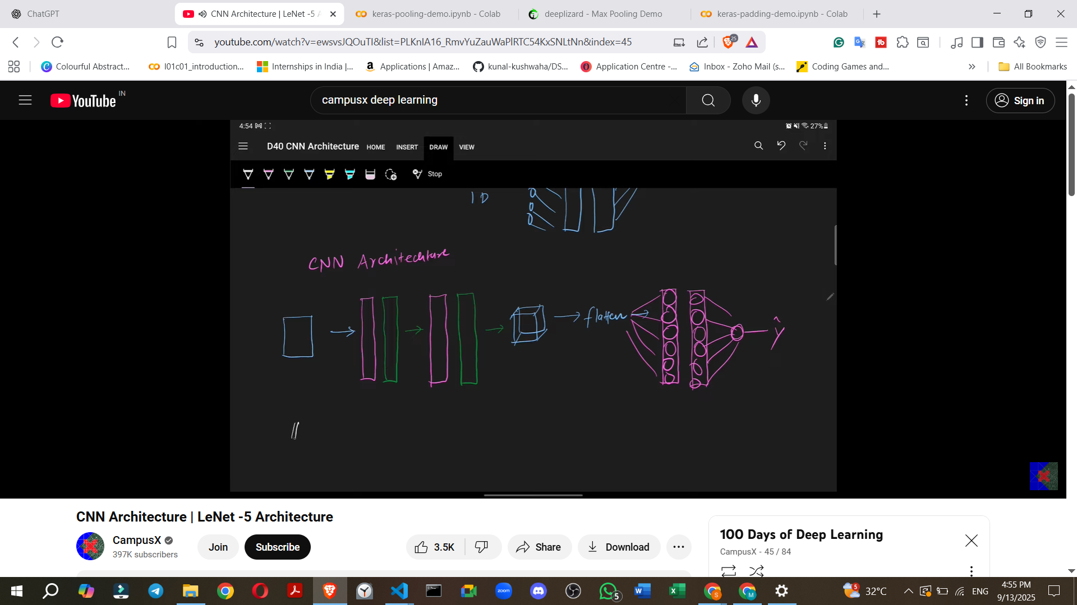

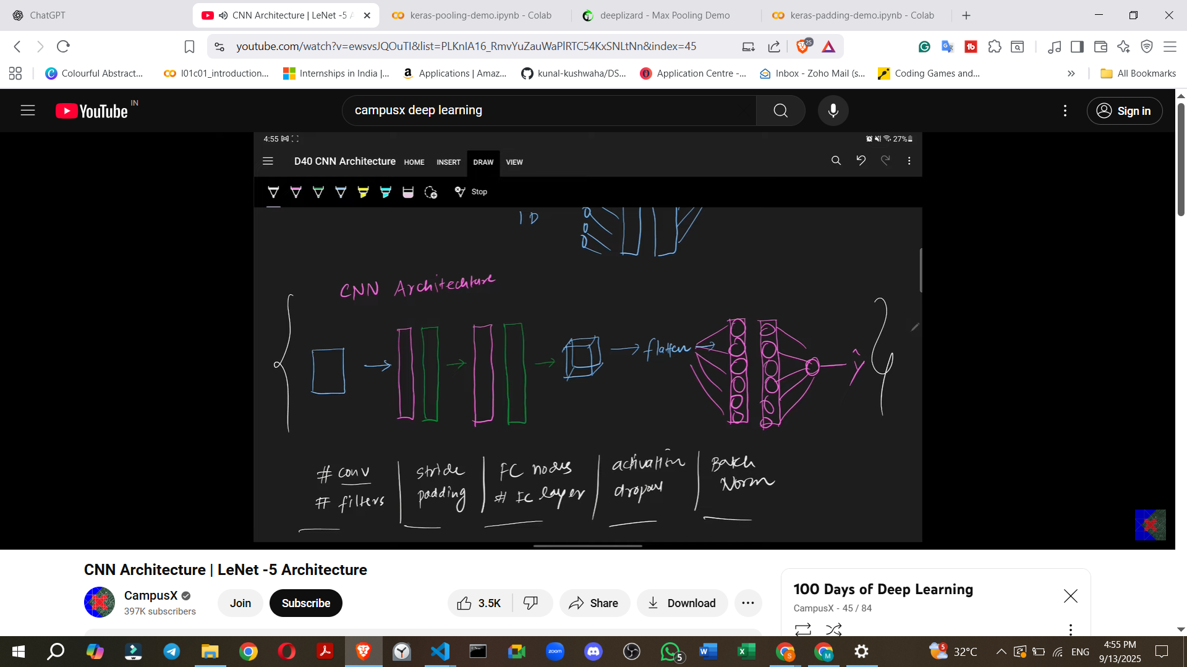

3. Variations in CNN Architectures
Different CNN architectures are created by varying several parameters of this basic structure:
- Number of Convolutional Layers: How many Conv + Pooling blocks are used?
- Number of Filters: The count of filters in each convolutional layer.
- Stride Value: The step size of the filter across the input.
- Padding: Whether padding is used (to preserve spatial dimensions) or not.
- Nodes in Fully Connected Layers: The number of neurons in the FC layers.
- Number of Fully Connected Layers: How many FC layers are present.
- Activation Function: The choice of non-linear function (e.g., ReLU, Tanh).
- Regularization Techniques: Use of techniques like Dropout or Batch Normalization.
- Examples of other famous CNN architectures (to be studied further): AlexNet, GoogLeNet, VGGNet, ResNet, Inception Module.
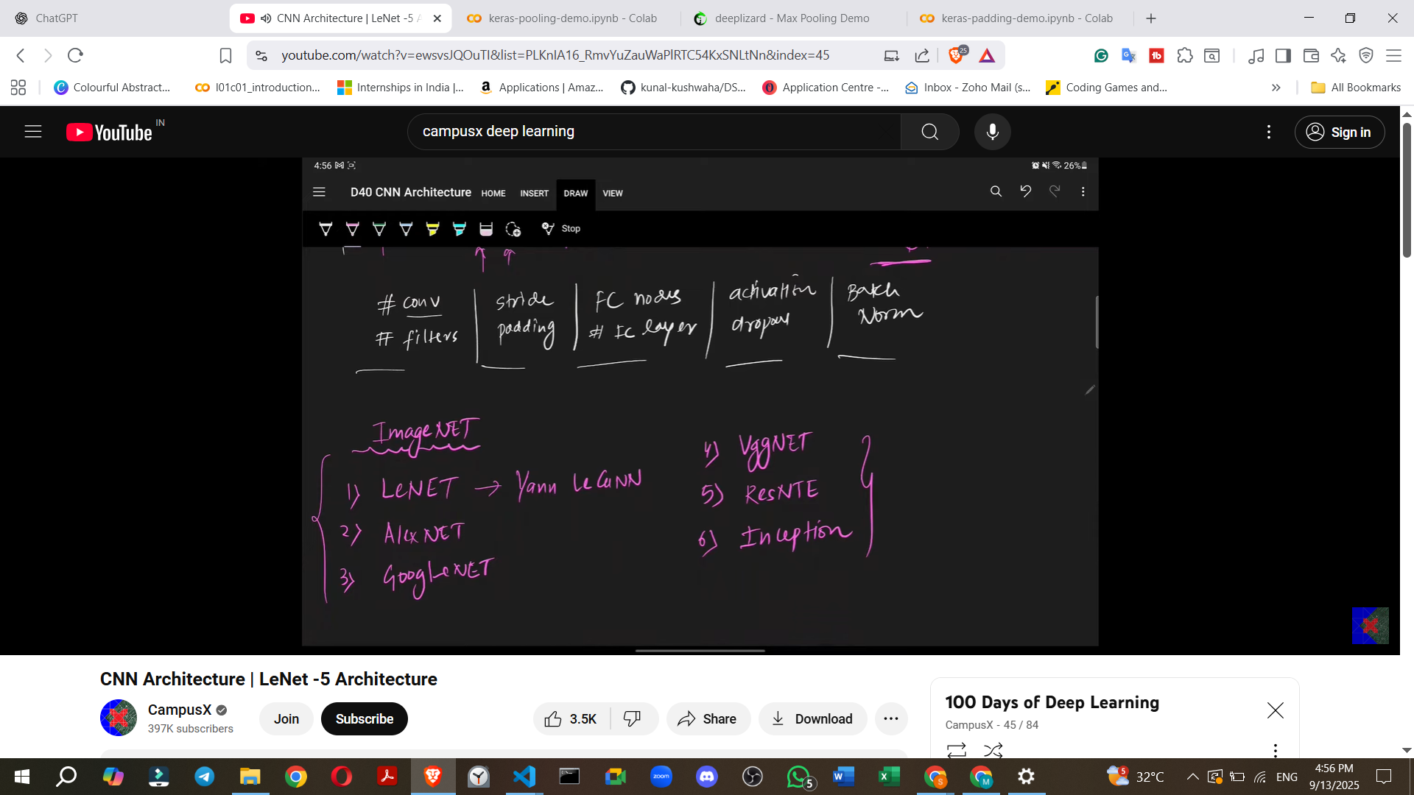

4. LeNet-5 Architecture: A Foundational Example
LeNet-5 is a crucial historical CNN architecture, often considered the first.
- Creator: Developed by Yann LeCun (regarded as the "father of CNN") in 1998.
- Purpose: Used for a project with the US Navy's postal service to recognise machine-written PIN codes (digit recognition).
- Name Origin: It is called LeNet-5 because it comprises five layers that are trainable (excluding the input layer).
- Key Observation: In CNNs, as you go deeper into the network, the number of filters generally tends to increase.
Let's break down the LeNet-5 architecture sequentially:
Input to LeNet-5:
- Input Image: LeNet-5 expects a 32x32 pixel grayscale image.
Layer-by-Layer Architecture:
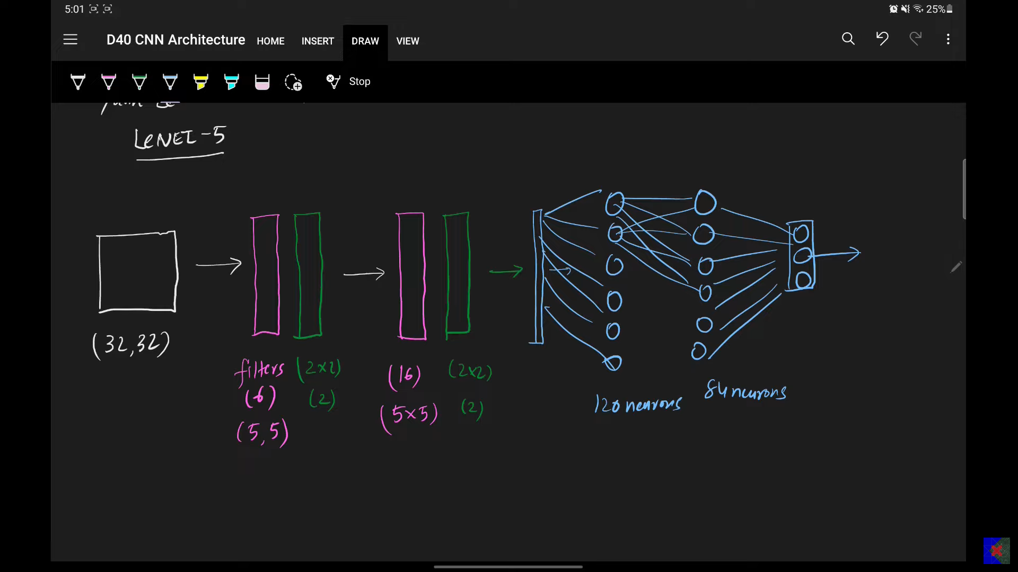
- Layer C1 (Convolutional Layer):
  - Filters: 6 filters.
  - Kernel Size: 5x5.
  - Stride: 1.
  - Padding: None.
  - Activation Function: Tanh (tangent hyperbolic).
  - Output Tensor Size: 28x28x6 (derived from 32x32 input, 5x5 filters, stride 1, no padding).
- Layer S2 (Average Pooling Layer):
  - Type: Average Pooling (not Max Pooling, which is more common today).
  - Pool Size: 2x2.
  - Stride: 2.
  - Output Tensor Size: 14x14x6 (28x28 input with 2x2 pooling, stride 2).
- Layer C3 (Convolutional Layer):
  - Filters: 16 filters.
  - Kernel Size: 5x5.
  - Stride: 1.
  - Padding: None.
  - Activation Function: Tanh.
  - Output Tensor Size: 10x10x16 (14x14 input with 5x5 filters, stride 1, no padding).
- Layer S4 (Average Pooling Layer):
  - Type: Average Pooling.
  - Pool Size: 2x2.
  - Stride: 2.
  - Output Tensor Size: 5x5x16 (10x10 input with 2x2 pooling, stride 2).
- Flattening Layer:
  - Purpose: Converts the 5x5x16 tensor into a 1D vector.
  - Output Size: 400 (5 * 5 * 16).
- Layer F5 (Fully Connected Layer):
  - Input: 400 neurons.
  - Output (Neurons): 120 neurons.
  - Activation Function: Tanh.
- Layer F6 (Fully Connected Layer):
  - Input: 120 neurons.
  - Output (Neurons): 84 neurons.
  - Activation Function: Tanh.
- Output Layer:
  - Input: 84 neurons.
  - Output (Neurons): 10 neurons (representing digits 0-9).
  - Activation Function: Softmax (for multi-class classification).
- Total Trainable Parameters: LeNet-5 has approximately 60,000 trainable parameters.
- Why Tanh and not ReLU?: In 1998, when LeCun developed LeNet-5, Tanh was considered the most effective activation function. ReLU, now widely used, was not the standard at that time.
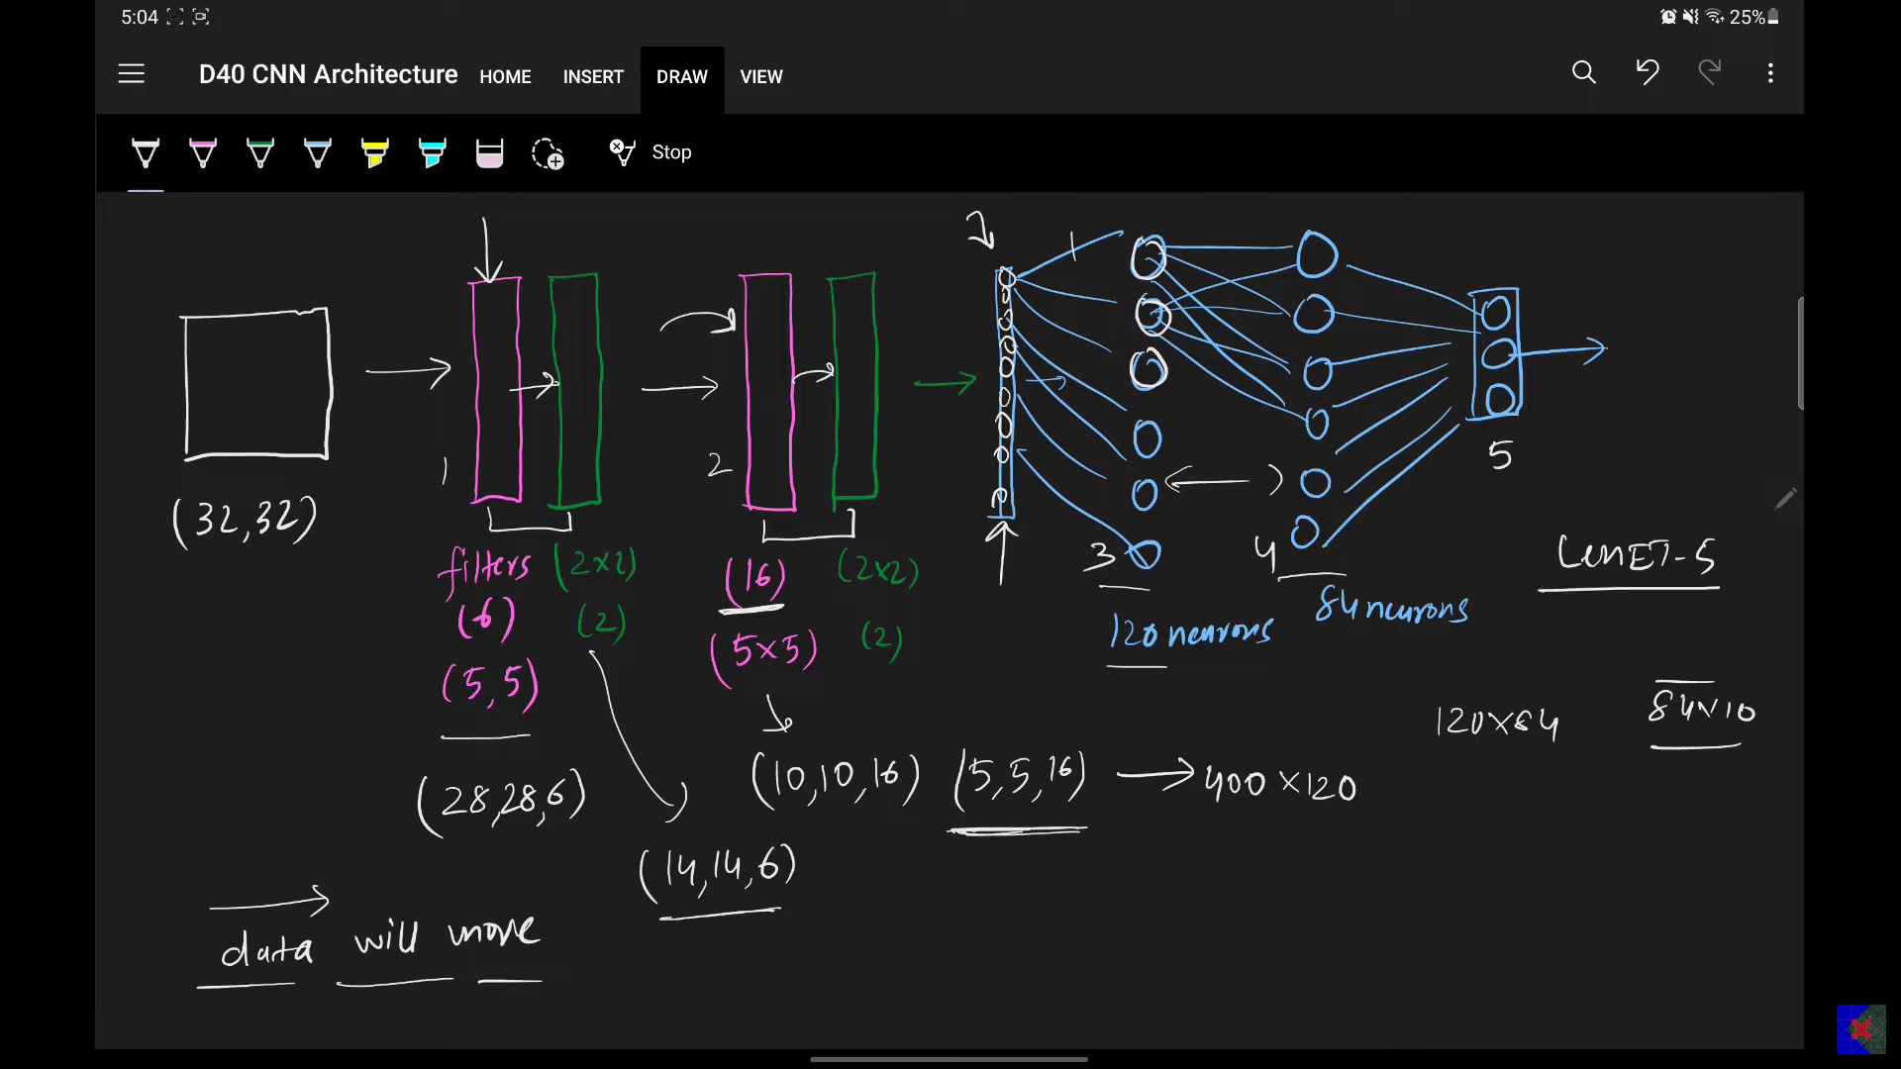

5. Implementing LeNet-5 in Keras
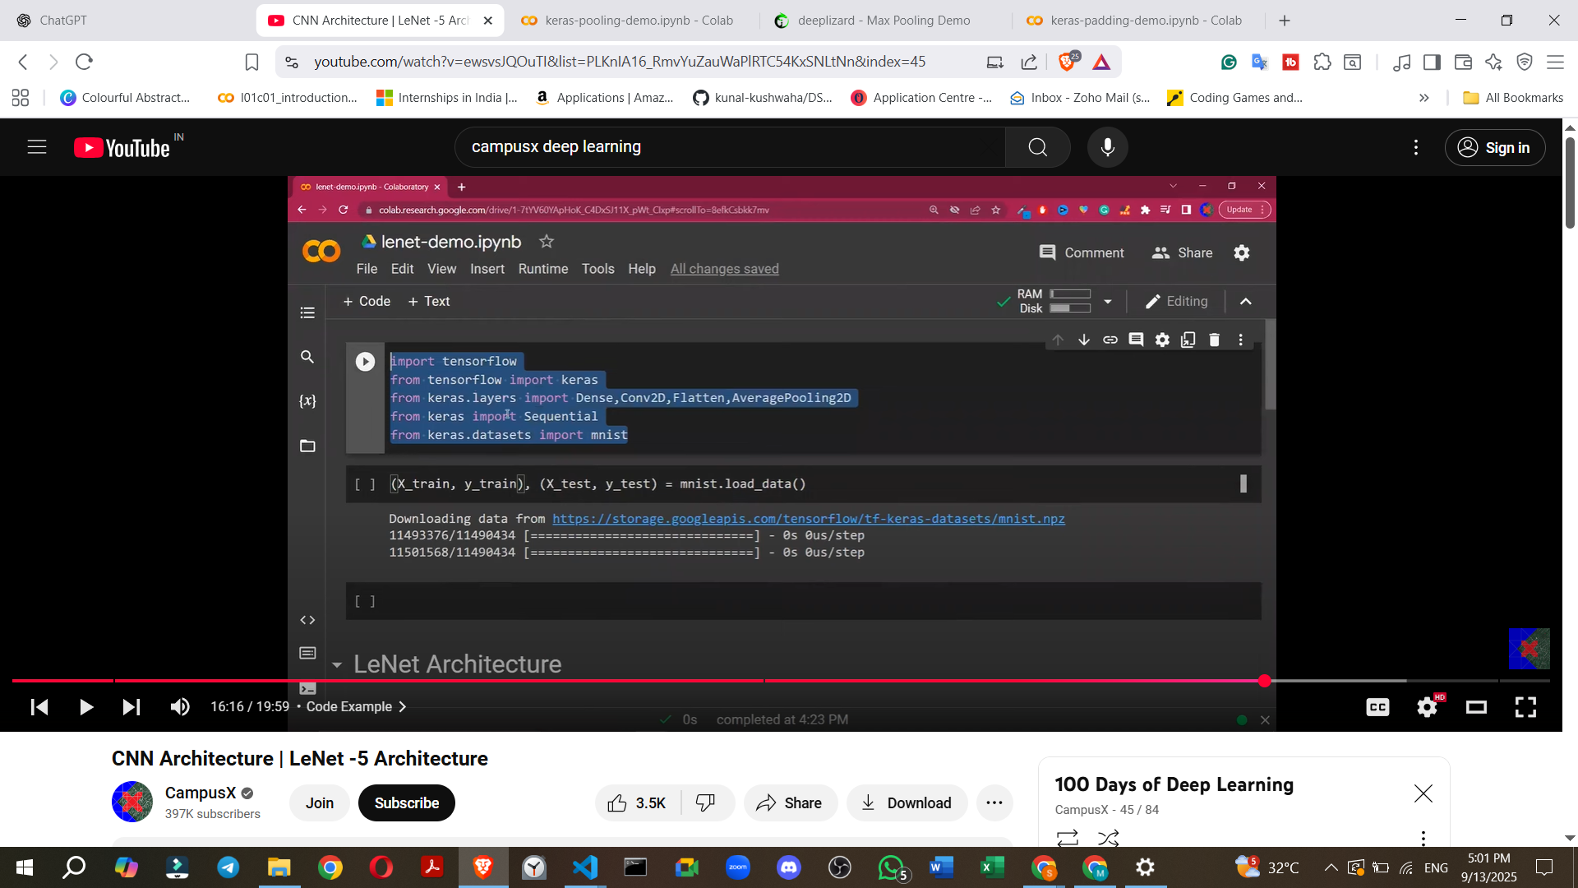
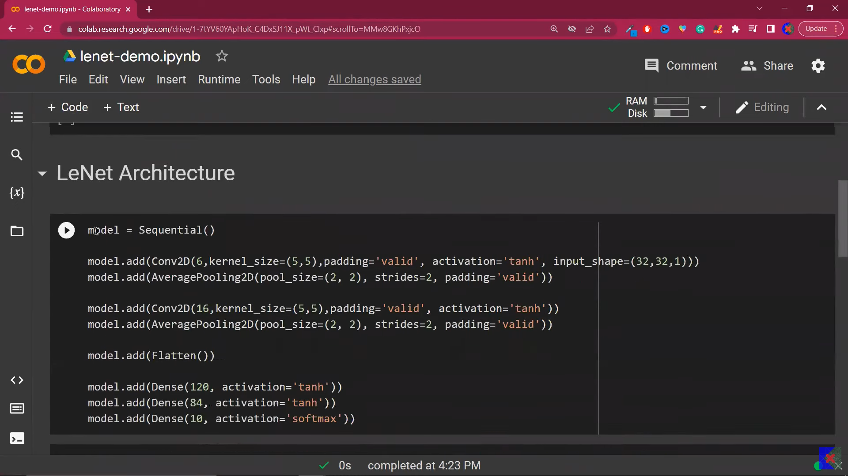
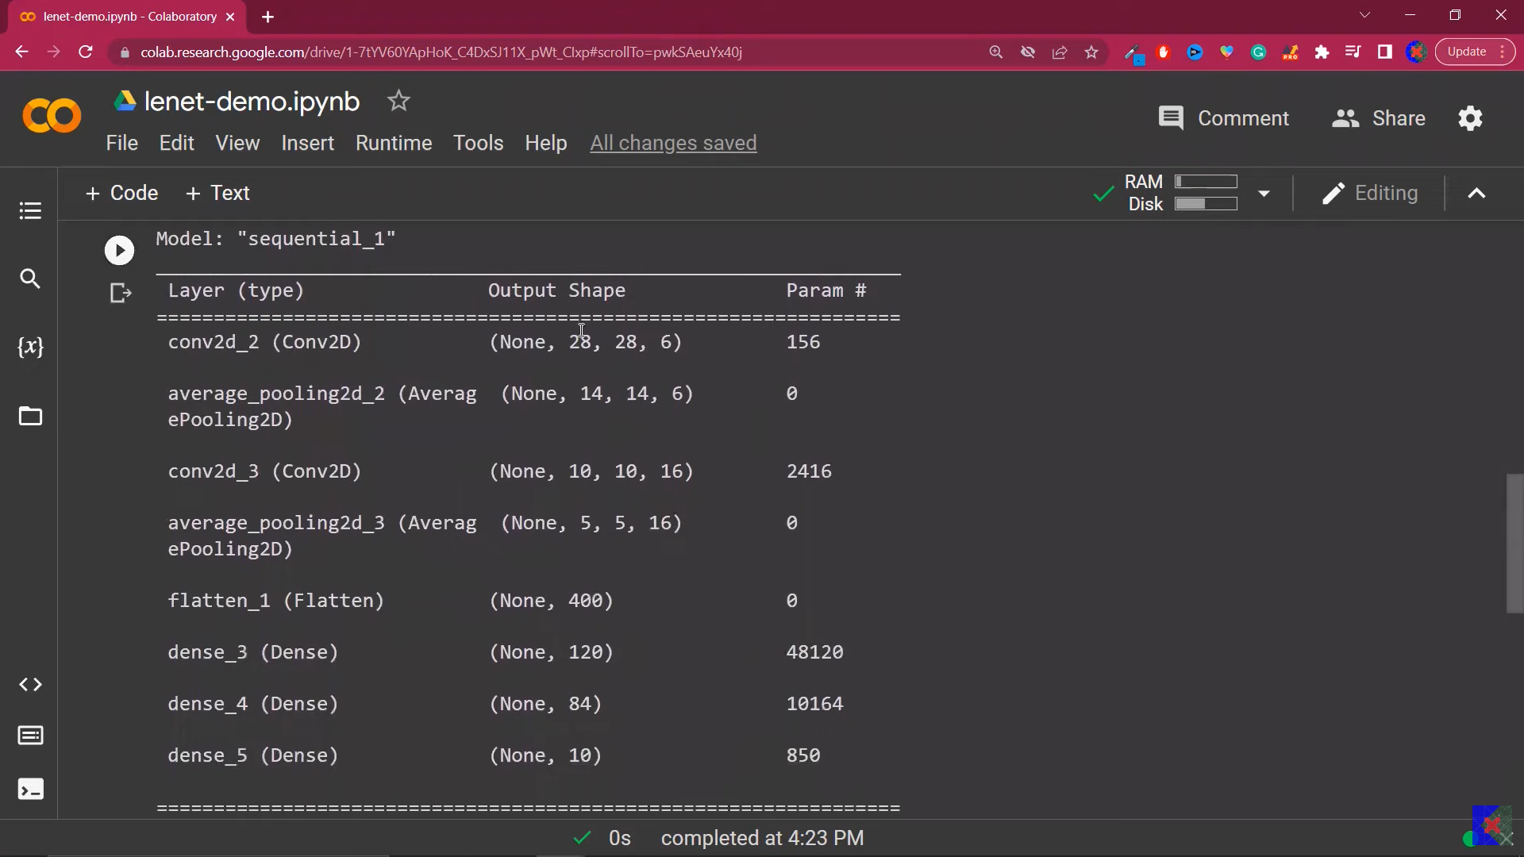
- The LeNet-5 architecture can be implemented using the Keras deep learning library.
- The implementation involves defining a sequential model and adding layers such as Conv2D, AveragePooling2D, Flatten, and Dense.
- Specific parameters like filters, kernel_size, pool_size, strides, and activation functions are set for each layer according to the LeNet-5 specification.
- The model can then be compiled and trained on a dataset.

6. Future Learning (What's Next?)
- The difference between CNNs and Artificial Neural Networks (ANNs) will be discussed.
- Creating custom CNN architectures for projects will be explored.
- Further discussions will cover more advanced CNN architectures like AlexNet, ResNet, VGGNet, GoogLeNet, and Inception Modules.

